**6115 – MAHENDRA INSTITUTE OF ENGINEERING AND TECHNOLOGY**

**AIR QUALITY MONITORING**

**TEAM : proj_223287_team_1**

**TEAM ID : 569**

**YEAR : |||**

**TEAM MEMBERS**

**SIDDARTH.K**

**SHAM.P**

**SARATHI.S**

**SASI KUMAR.V**

**SATHISH KUMAR.K**

**SENTHIL MURUGAN.R**

**MENTOR NAME : SANTHANARAJ.M**

**AIR QUALITY :**



* Air quality refers to the degree to which the air is suitable or clean enough for humans or the environment.
* Good air quality means the air is free of harmful substances.
* Air quality is a measure of how clean or polluted the air is.

**IOT AIR QUALITY :**

The term IOT, or Internet of Things, refers to the collective network of connected devices and the technology that facilitates communication between devices and the cloud, as well as between the devices themselves

.

  Air quality sensors are deployed in strategic locations to measure pollutant levels such as particulate matter, gases, and volatile organic compounds

Smarter Technologies' smart air quality monitoring devices are able to detect carbon dioxide levels, noxious gases and pollutants, sending real-time data to a central management dashboard.

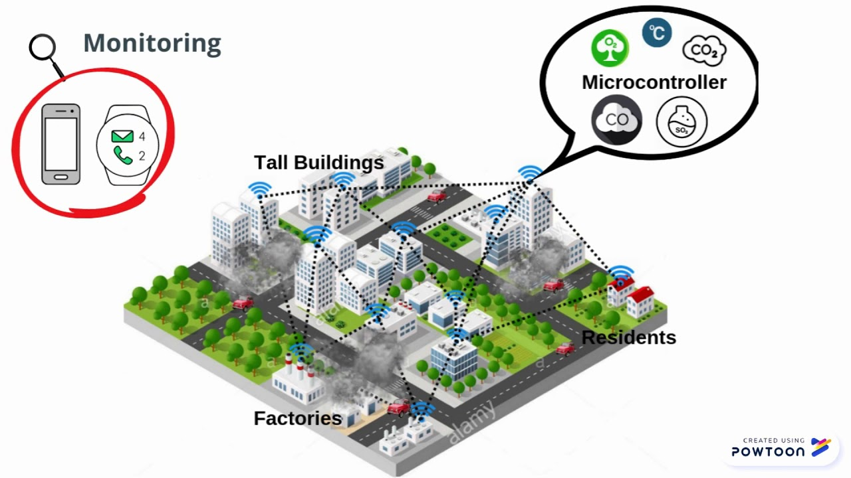

**TOXIC GAS DETECTION :**

**The IOT-powered air quality monitoring system is well-equipped with advanced sensor devices and gateway connectivity that is functioned to detect the presence of toxic gases within the premises. The solution is interlinked with the smart device of the user and allows him to take immediate actions in case of disasters. Thus, an IOT-powered system is an essential add-on in the industry to reduce the chances of gas explosions, fire hazards, and other naturally occurring calamities. The industry managers have complete control over the IOT-solution and can take appropriate actions as soon as they receive emergency triggers on their devices, thus reducing the maintenance and operational costs of the industry.**

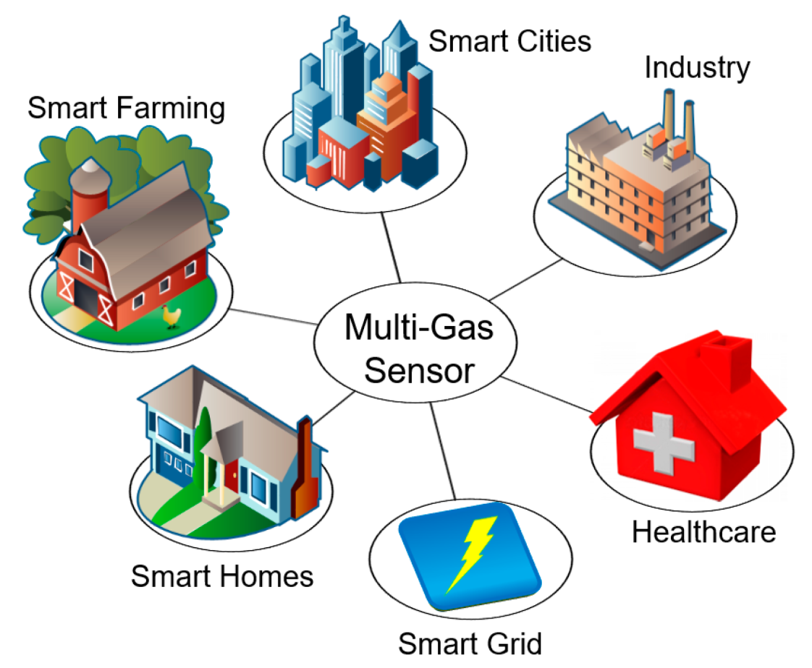

**TEMPERATURE AND HUMIDITY MEASUREMENT :**

**IOT technology is an effective concept that contributes to measuring the temperature and humidity ratio within any industrial premises. It helps the authorities in maintaining a proper ambiance required for the workers to work under certain environmental conditions by keeping real-time control on the IOT-powered solution. The temperature and humidity monitoring helps analyze the situation and maintains a favorable environment as required. Moreover, in the case of mining industries, an IOT-powered air quality monitoring system detects the oxygen levels, thereby keeping the employees safe in case of any decrease in the levels. It allows them to evacuate the premises as soon as there is any decrease in the oxygen levels.**

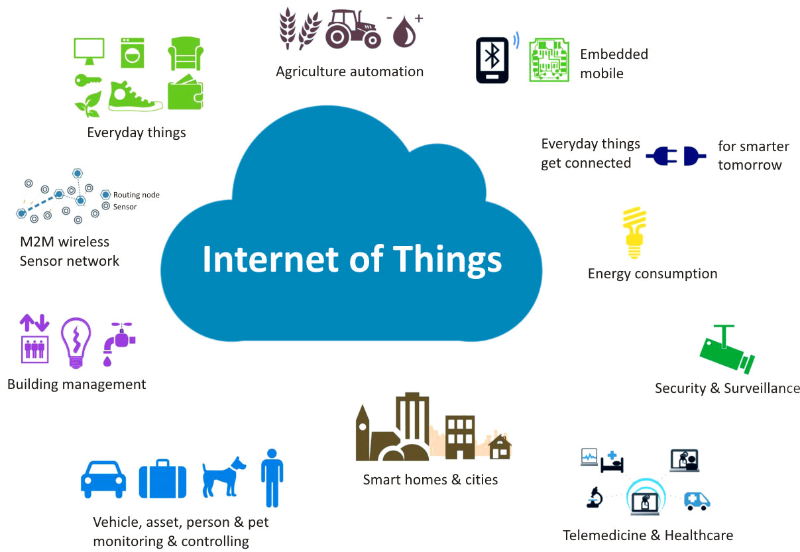

## Air Quality Monitoring BENIFITE

Air quality monitoring is an important tool for improving air quality, protecting public health, and ensuring compliance with regulations. It can also be used to identify pollution sources, monitor climate change, or support research and development.

Air quality is not same everywhere and it is different by geographic pattern and weather conditions along with sources of air pollution contributes towards the quality of air.



**\*!*THANKING YOU*!\***